# The Battle of Pharsalus

* Julius Caesar defeats Pompey 45,000 army with only 22,000 men.
* The War technique used by Caesar was Inverted V (used when all Pompey army was engaged and Caesar lines were set free).
* Calvary (fast army troops usually horses are used for the fast and rapid attacks i.e Exploration)
* Exploration can be reduced by the time because these are less in number and the first ones to engage in a fight.
* The 4 major army troops used in the fight was:

1. Hastati
2. Principe’s
3. Pilani
4. Calvary

* Deployment of the troops
* Caesar made 3 categories archers, Calvary troops and armed troops
* Armed troops are then arranged again in a cohort manner in which the first 3 mentioned above troops were arranged randomly.
* Caesar formed 9 Legions (new name battalions) 1800 men each.
* Each legions contains 30 men platoon which is further used for making the V around the enemy forces.
* Every Army legion has a commander which has the best fitness among them.
* The Main commander is placed at the best position and all the commanders of legions follow the main commander.
* The troops are spread in the way the tactical troops make a V around enemy troops.
* When the army sees some enemy troops they form a V formation around the troops and keep on exploiting the area when all the enemies are either dead or captured.
* After attack the formation is then changed (commanders and frontier men which gain more experience In the could be replaced)

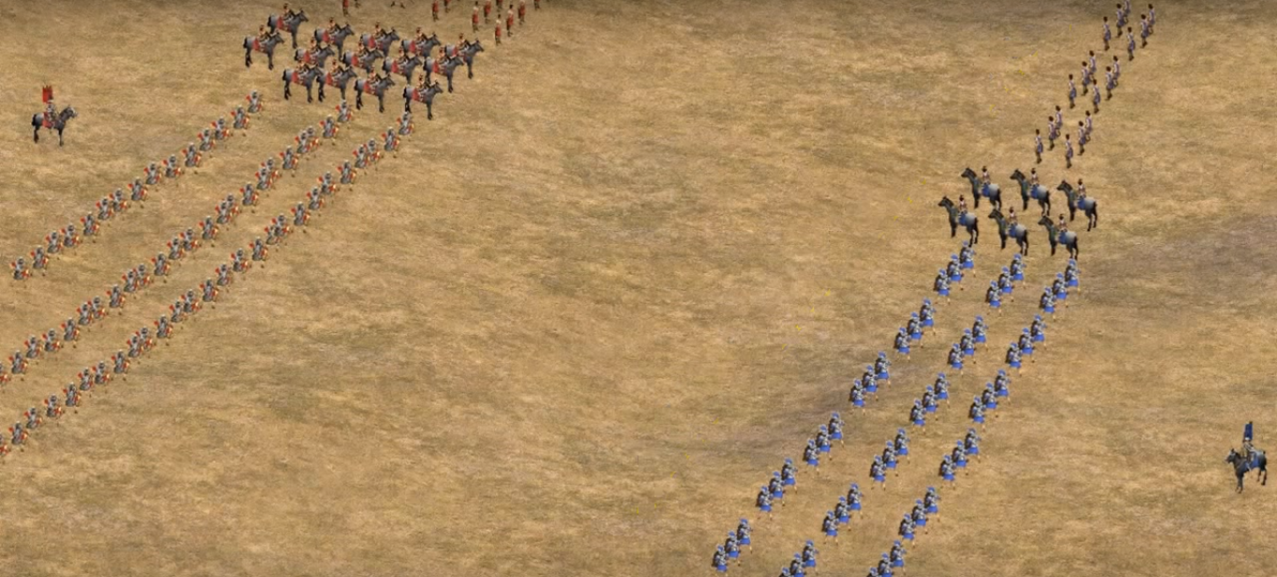

**Figure of Troops Arranged Blue army is Julius Caesar’s**